1v1 & 2v2 SESSION

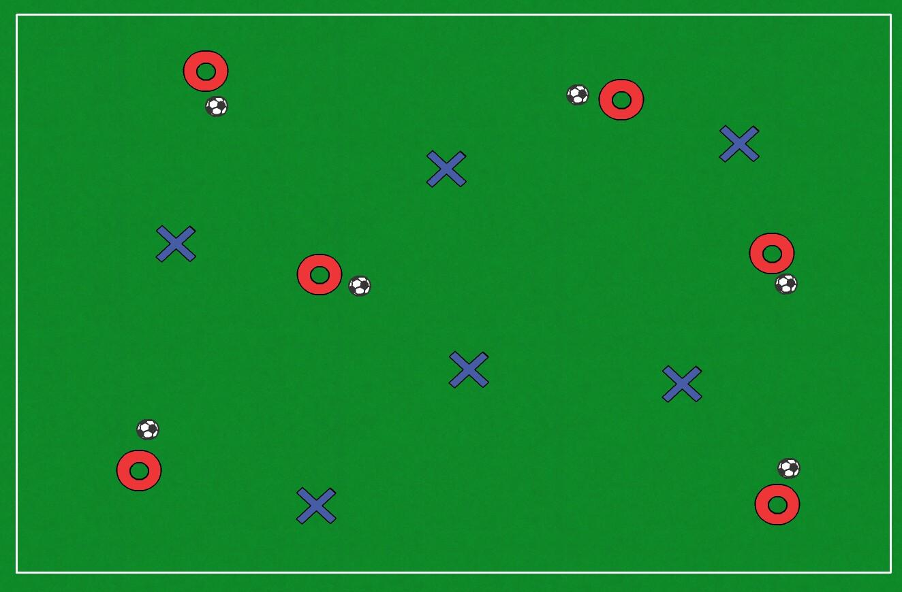

KEEP BALL

- Split group in half
- Half the group has a ball each
- The other half has to try and win a ball
- Play for 30 seconds
- Did anyone that started with a ball manage to keep it throughout?

Coaching points

- How can you use your body to shield the ball?
- Can you find find space?
- Can you make the tackle and keep hold of the ball?

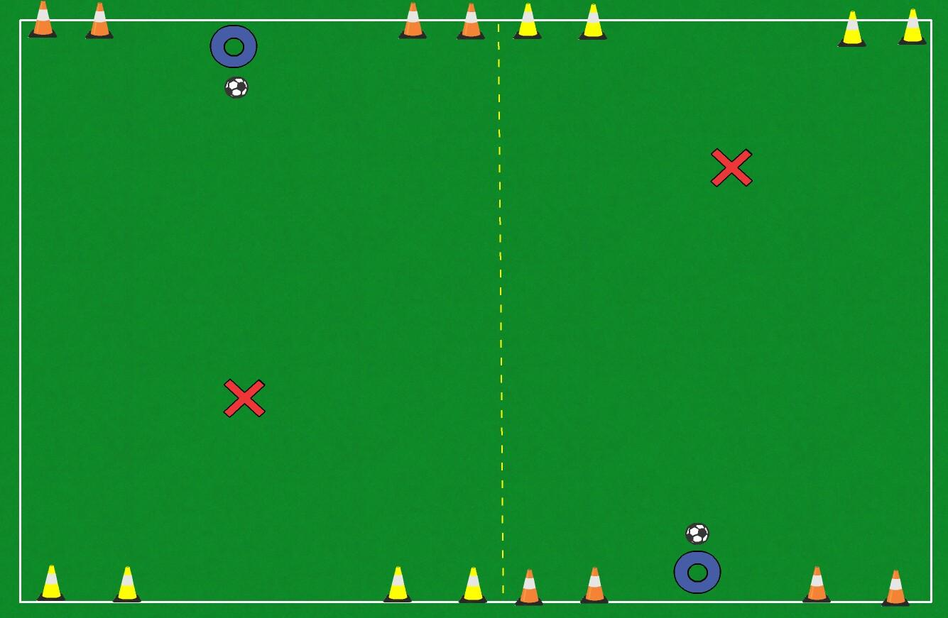

1v1

- Play 1v1
- Play for 3 minutes
- Dribble through one of the two goals to score
- Winners move up a pitch, losers move down

Coaching points

- How can you beat a player?
- How can you use your body to help you keep the ball?
- Can you try one new thing in each game?

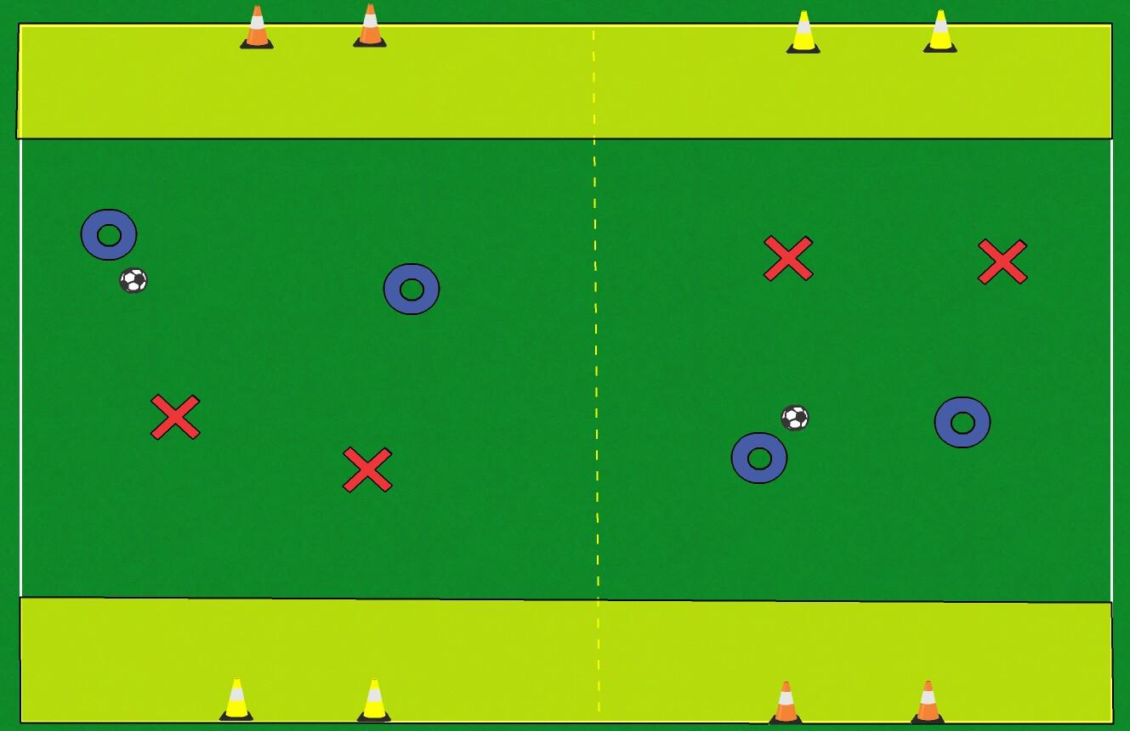

2v2

- Play 2v2
- Play for 3 minutes
- Have to be in the highlighted target area to score
- Winners move up a pitch, losers move down

Coaching points

- How can you beat a player?
- How are you going to attack against two?
- How are you going to defend against two?
- When to dribble & when to pass?
- Can you try something new each game?

SESSION OUTCOMES

- Shielding the ball, body between ball and player, be as big as you can
- Having a quick scan to find space or team mate
- Tackling to keep the ball and counter attack
- Beating a player 1 on 1 by tricking them to get them off balance
- Decision making in attack and defence

