1v1 SESSION

WARM UP

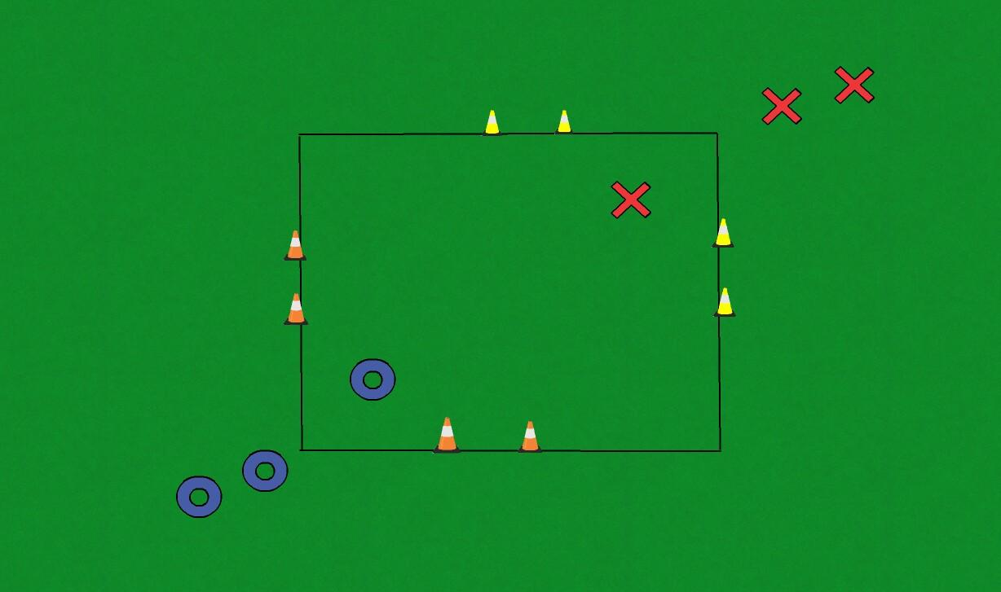

This is an evasion game warm up. In turns, one blue will try to evade one red and escape through the yellow cones. Reds are looking to tag the blues.

- Blue team go first
- Red team then has a go at evading the blues
- Who can get the most players from their team through the gates?
- Run through practice twice
- What are the best ways to evade a player?

PROGRESSION ONE

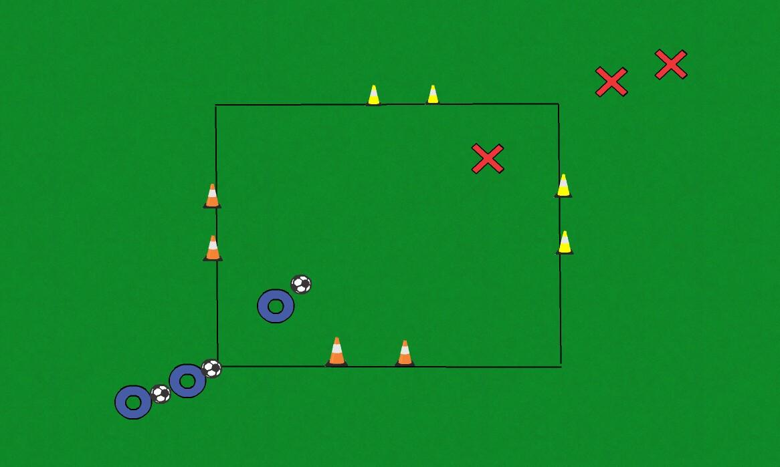

Blues to start with the balls and one at a time look to beat their red opponent. To score a point the blues must dribble through either yellow gate. If a red wins the ball from from a blue, they then try and dribble it through either orange gate.

What worked well? What didn't work? Why?

PROGRESSION TWO

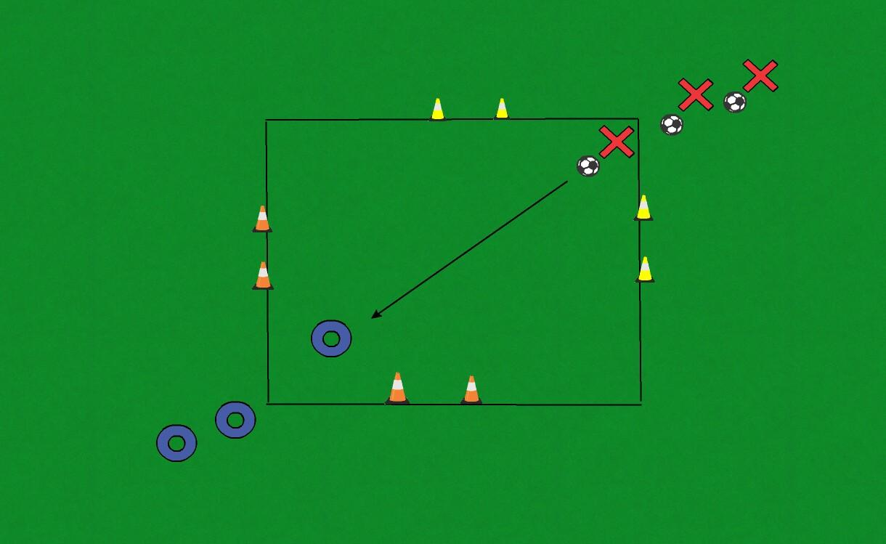

In this progression red passes to blue before attacking to dribble through one of the two yellow gates. Once all blues have had their attempts we'll test them against the reds.

How does your first touch help you beat a player?

END OF SESSION GAME

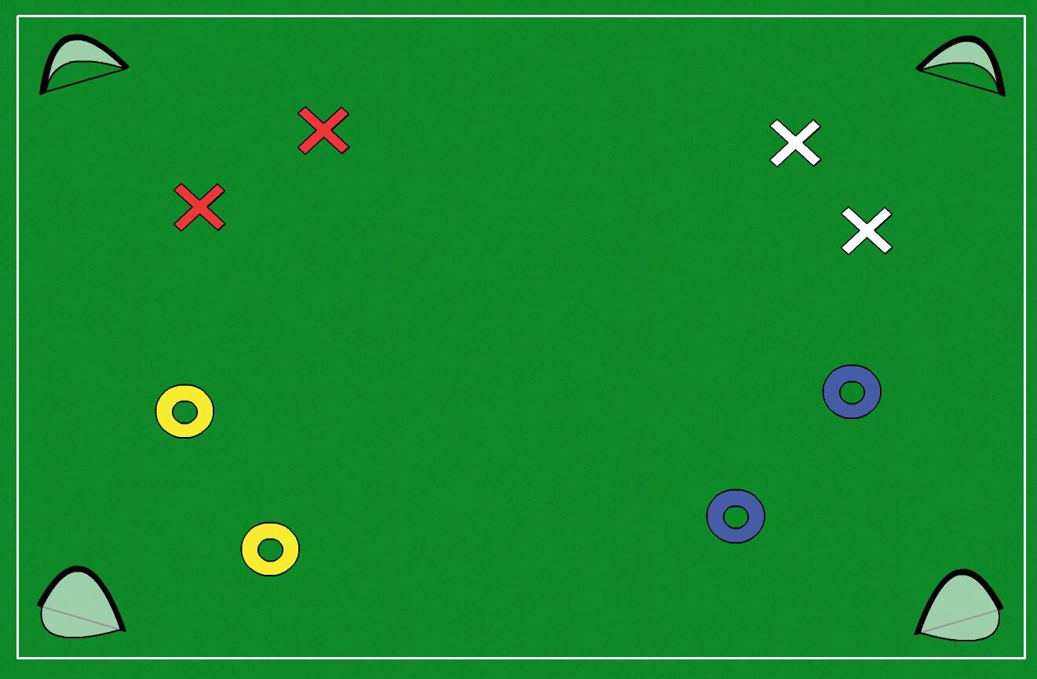

This end of session game consists of four teams playing two matches across the same pitch. This will give the players a busy environment to practice their newly tested 1v1 techniques in.

Can you dribble past a player and score?

