BALL PROTECTION & DRIBBLING 1v1

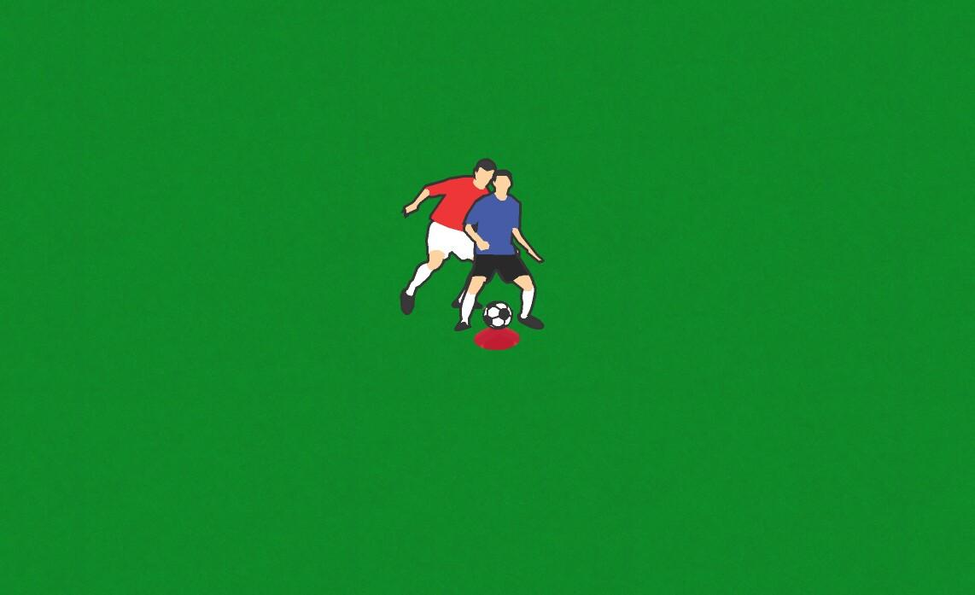

Arrival Activity

- In pairs, one take a cone and one take a ball
- Place the ball on the cone
- One player tries to protect the ball, whilst the other tries to knock it off

Coaching Points

- Can you protect the ball by standing side on with your arm out?
- Do you know where your opponent is?
- Can you knock the ball off by tricking the protector?

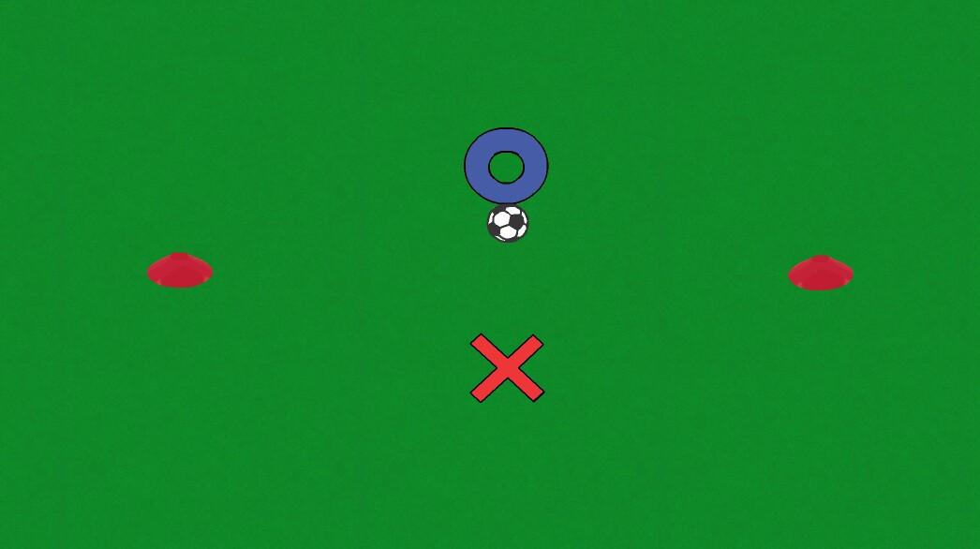

Practice One

- Two cones five paces apart
- One player with the ball and one without
- Player with the ball has to trick the player without to beat him to either cone
- If you are aiming for the cone on the right then you need to stop the ball with your right foot
- If you are aiming for the cone on the left then you need to stop the ball with your left foot

Coaching Points

- Can you trick your opponent to get them off balance?
- Can you travel at speed and remain in control of the ball?

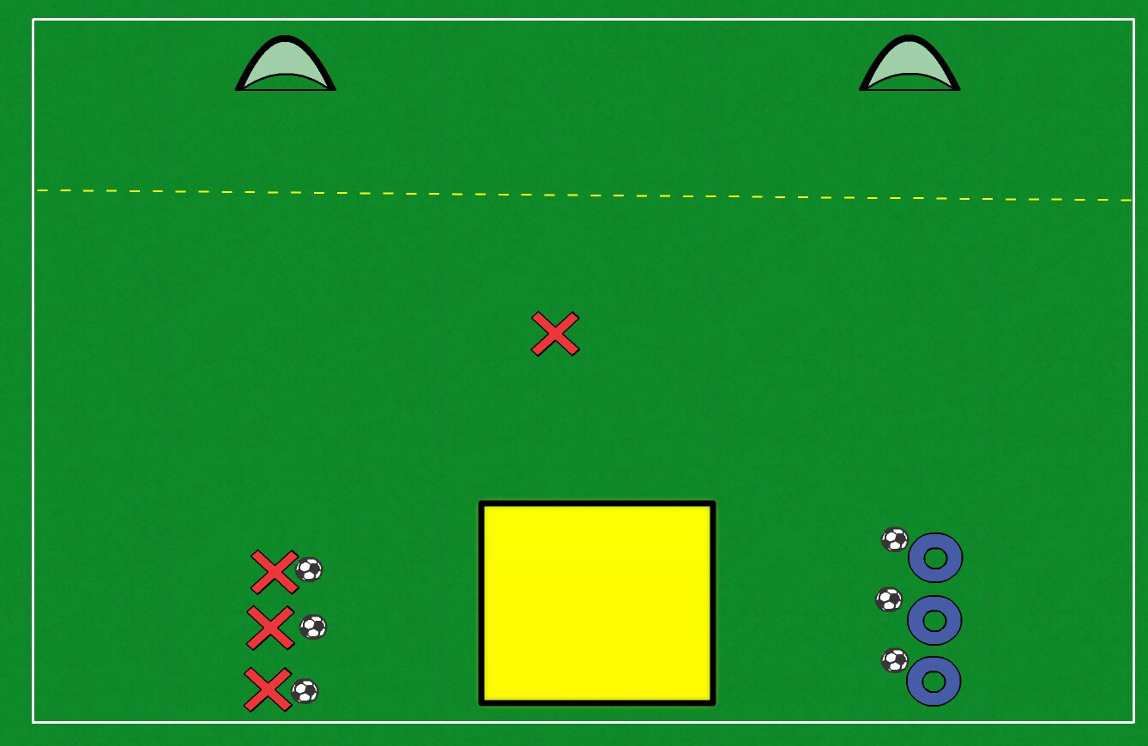

Practice Two

- Setup two target goals and a striking area as shown
- Players play 1v1 and attack either goal
- Attacker looks to score in either target goal
- Defender looks to win possession and dribble into the yellow box
- After each turn the attacker becomes the defender
- Play restarts as soon as the 1v1 is dead
- 1 point awarded for the nearest goal
- 2 points awarded for the furthest goal
- 3 points awarded for winning possession and dribbling into the yellow square

Coaching Points

- Can you trick the opponent to gain an advantage?
- When to run with ball and when to slow it down?
- Can you get back into position quickly in transition?
- When to tackle and when to stand off?
- First touch into space, which goal are you going to attack? Scan

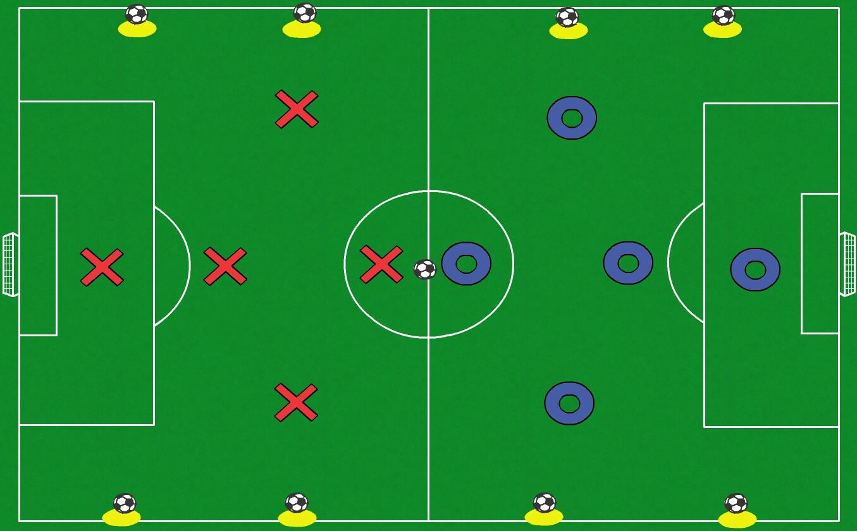

Game

- Play 5v5
- When a ball goes off the pitch the player that kicks the ball out must retrieve it
- Once the ball goes off the team that now has possession restarts play by getting a ball off a cone
- Whilst the player retrieves the ball the match continues giving one team a player advantage

Coaching Points

- Focus on beating players in 1v1 situations
- Can you make the most of it when you have the numerical advantage?
- Will you attack quickly if you have the man advantage?
- Will you hold up the play or try to attack if you have the disadvantage numerically?
- Can you attack space? Scan

Session Outcomes

- Shielding the ball - body between the ball and the defender
- Ways and when to trick your opponent - dummies, feints
- When to dribble at speed and when to slow it down
- Check for space - scan
- When to make the tackle and when to stand off

