PASSING & MOVING

WARM UP - TAG

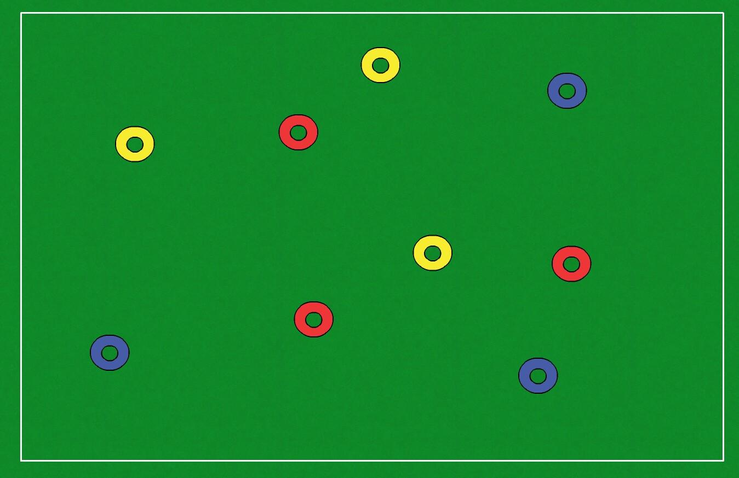

- Three teams, one of the teams will be taggers
- Once you've been tagged you stand on one leg
- You can rejoin the game once a member of your team has tagged you
- Play for one minute
- Each team has a go at being taggers
- Can you go the whole minute without being tagged?
- Can your team finish the minute with everyone free?

PASSING & MOVING UNOPPOSED

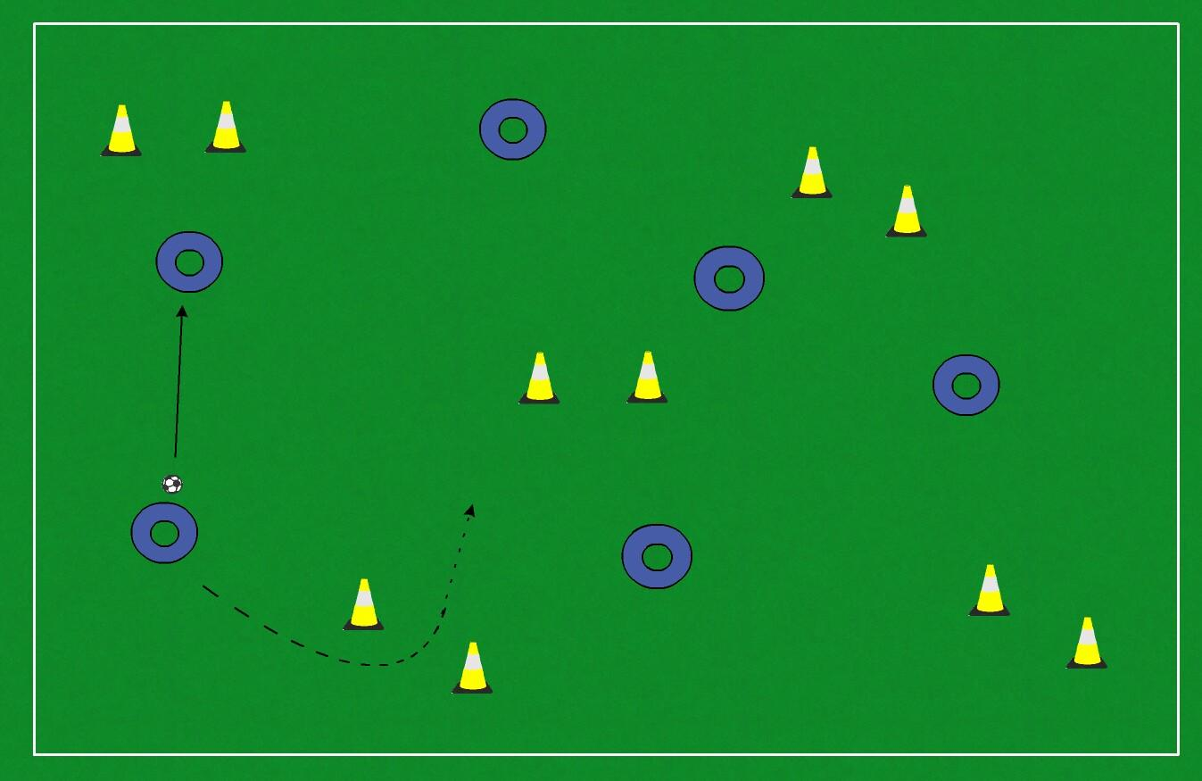

- Pass the ball between your team
- After you've played a pass you must sprint through a gate
- Play for one minute
- Can you complete more passes between your team than the other team?

PASSING & MOVING OPPOSED

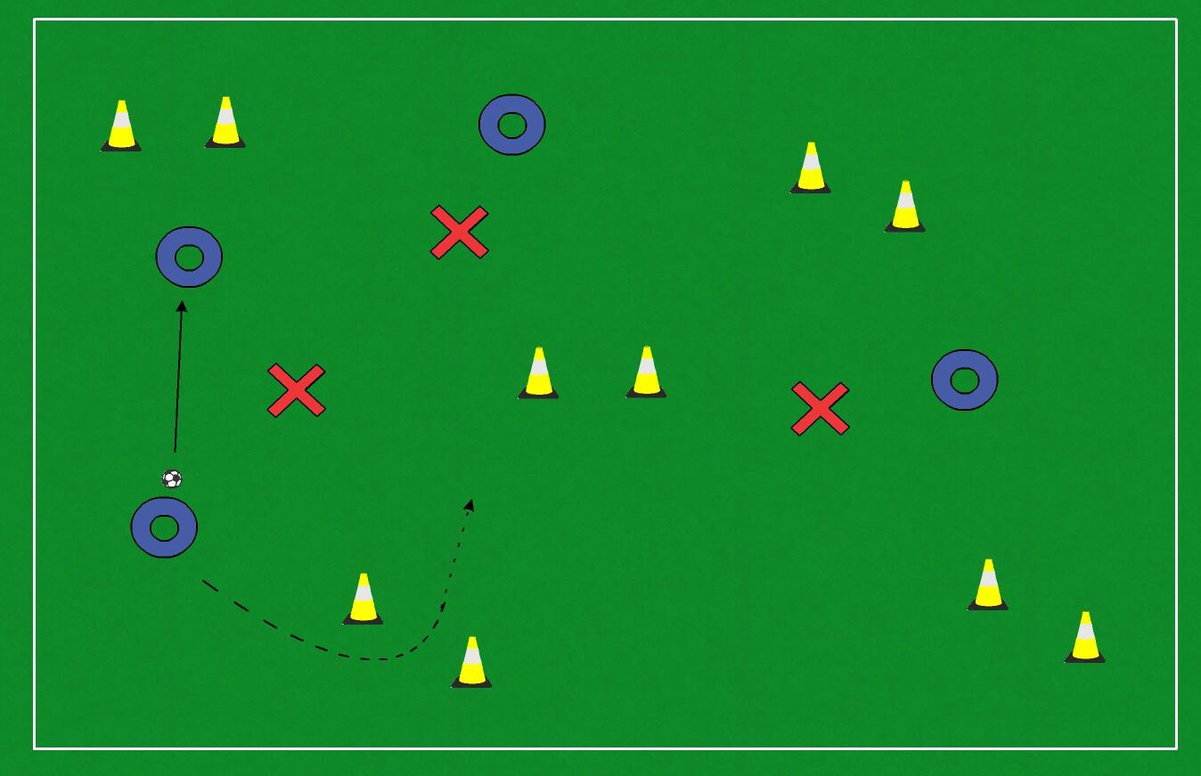

- The practice is progressed by adding a defender
- Begin with one defender, add further defenders based on ability of your team
- Play for one minute or until the ball is retrieved by a defender
- If a defender wins the ball, he then swaps with the player he won the ball from and the minute restarts
- Can a team hold on to the ball for the whole minute?

FOUR GOAL FOUR TEAM MATCH

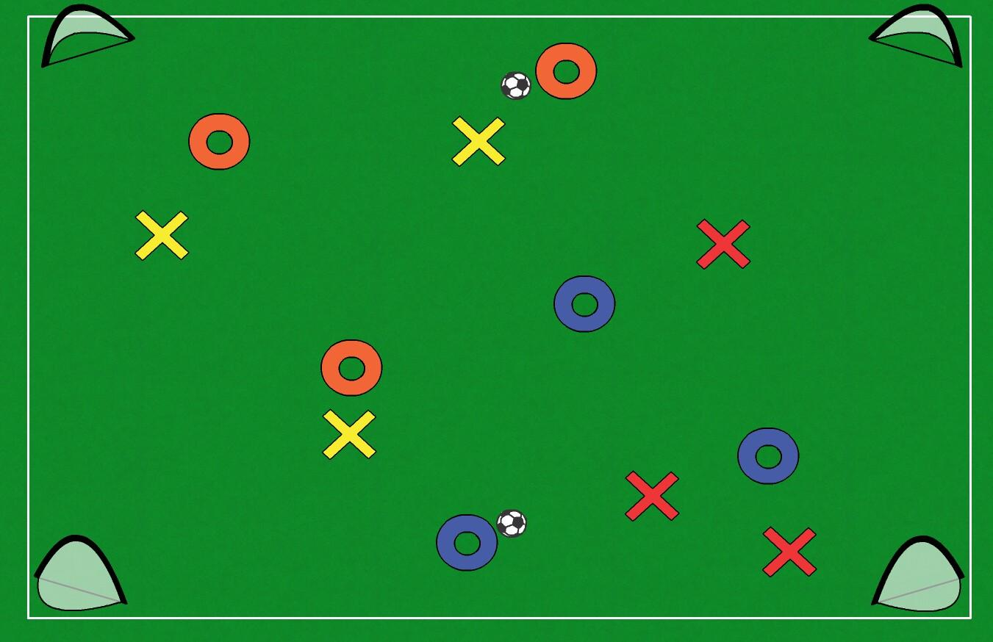

- Start with four teams
- Team 1 vs team 2 & team 3 vs team 4
- All teams can score in any of the four goals
- Can we use passing and moving to help create a goal scoring opportunity?
- This game is very busy with lots of decisions for the players to make both with and without the ball

OVERVIEW

- Physically demanding session
- Focus on quickly finding space after pass
- Lots of decision making
- Will aid reaction times
- Potential for lots of goals in the four team game

